Instructions for presenting your city and biome
- State the kind of biome the city is in. Make this the Title.
- Include a small picture of the continent your country is in. Mark the place where your city is on your map.
- Write a small introduction to the place, its location and the kind of biome it resides in.
Example:
The Tropical Rainforest Biome
Lima, Peru, South America
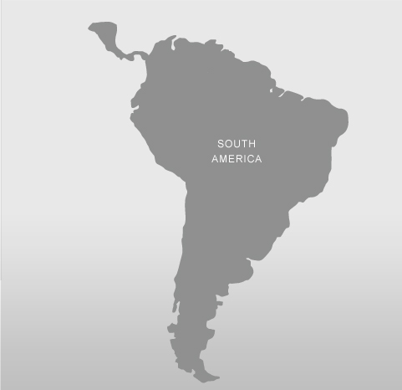
On the northwest coast of South America,
lays the city of Lima, Peru. This city is in a
tropical rainforest.

My imagined picture of a rainforest
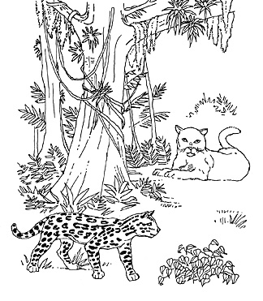

- Write about:
  - Where this biome is located
Ex. The permanent ice biome can be found in Antarctica,
Greenland and around the North Pole.
  - Some prominent physical features of this biome
  - 3 plants and 3 animals you can find in this biome
  - Precipitation in this kind of biome
  - Temperature in this biome
Make sure what you write is short. You are not supposed to reproduce all of the information presented in the text, you are only presenting some of the MAIN features of this biome.
- Draw a picture that represents your biome for you. Include physical features, animals and plants.

Biome Identity
Student Name: _____________________________________

CATEGORY | Excellent (5) | Good (4) | Acceptable (3) | Not Acceptable (2-0)
Biome Identity | Your city's location is properly and clearly identified. The biome in which your city lays is properly identified, and used as the title of your biome project. The locations in which this type of biome can be found are all identified. | The biome you identified is correct, but you missed a location in which it can be found. | The biome you identified is correct, but you missed a number of locations in which it can be found. | The biome you identified your city as being in is incorrect, or many of the locations in which this biome is found are not noted.
Climate | The normal ranges for temperature and precipitation are stated correctly. | The normal ranges for temperature and precipitation are stated but are missing part of their range. |  | The ranges for temperature or precipitation are not stated.
Physical features | Key physical features are identified. | One key physical feature of your biome is missing. | Many key physical features in your biome are missing. | No key physical features are identified, or the wrong features are identified.
Biotic Features | 3 animals and 3 plants from the biome are properly identified. | You are missing a plant or animal, or have identified one incorrectly. | You are missing two plants or animals, or have identified one incorrectly. | You are missing three or more plants or animals, or have identified one incorrectly.
Map | A map of the continent in which your city is located is well drawn (not perfectly). The location of you city is clearly and properly shown on the map. | The map you drew is messy and inaccurate, but can be understood. The city is located in approximately the correct location. |  | Your map can not be understood, or the location of your city is completely wrong.
Picture | Your picture includes key features (biotic and/or abiotic) that make it easily recognizable as this particular biome. | Your picture is not easily identifiable as the biome stated. |  | There is no picture.

Instructions for constructing your climatograph
- PLAN YOUR CLIMATOGRAPH. Analyze your data. Figure out what your range for precipitation and temperature will need to be. Your graph will look different than your classmates.

  - Write the number of divisions you will need for each axis.

    - X-axis____ Y-axis(1)____ Y-axis(2)____

  - Write the units for each division.

    - X-axis____ Y-axis(1)____ Y-axis(2)____

  - Write the difference between each division.

    - X-axis____ Y-axis(1)____ Y-axis(2)____

- Using only the right side of your large paper, use a pencil to construct a graph on which your data can be graphed.
  - Sketch out a quick draft on regular sheet of paper to make sure everything fits before committing to your good copy.
  - Leave enough space above for your graph’s title.
  - Leave enough space below to label your y-axis and a legend.
  - Leave enough space on either side to label your x-axes.

- Construct your climatograph.
  - Make outlines in pencil first so that things can be changed if they need to be
  - Add in numbers and labels.
  - Add a legend.
  - Fill things in using color. Make it look great!!!

- The left side of your paper will be used for something else….
Your biome…

Climatograph Rubric

Name______________________________ Date____________________

CATEGORY | Excellent (5) | Good (4) | Acceptable (3) | Not Acceptable (2-0)
Axes | Each axis must:  - Be drawn with a ruler  - Be parallel with the paper's edge  - Have even divisions  - Be properly labeled with quality and units | One or two of the aforementioned details is not of good quality. | a few of the aforementioned details is not of good quality. | Many of the aforementioned details is not of good quality.
Title | The title is displayed prominently at the top of the graph. The title clearly displays the graph's topic. | The title clearly displays the graph's topic. The title however is not very prominent. | The title is missing some key information. | No title is present.
Temperature | Temperature is conveyed clearly and accurately as a line graph. This graph does not intersect the Precipitation graph. | Temperature is conveyed clearly and accurately as a line graph. This graph intersects the Precipitation graph. | Temperature is conveyed accurately as a line graph, but is not very clear. | Temperature is not conveyed clearly and accurately, or is not a line graph.
Precipitation | Precipitation is conveyed clearly and accurately as a bar graph. This graph does not intersect the Temperature graph. | Precipitation is conveyed clearly and accurately as a bar graph. This graph intersects the Temperature graph. | Precipitation is conveyed accurately as a bar graph, but is not very clear. | Precipitation is not conveyed clearly and accurately, or is not a bar graph.
Legend | Legend is included in a box. It is clear and neat. | The legend is clear, but is not very neat. | The legend is not very clear. | The legend is missing.
Neatness | All lines are straight. Coloring is neat. The climatograph looks good enough to be a professional poster! | All lines are straight. Coloring is neat. | Some lines are not straight or coloring is messy. | The climatograph is messy and unattractive.

