Name:_______________________________________

Plant Cell Coloring
Cell Membrane (Light brown)  Nucleoplasm (dark yellow)  Mitochondria (red)  Vacuole (pale Blue)  Chromatin (gray) | Cell Wall (dark green)  Nucleolus (black)  Chloroplasts (light green) | Ribosome (orange)  Cytoplasm (light yellow)  Golgi Apparatus (pink)
Smooth Endoplasmic Reticulum (light blue)
Rough Endoplasmic Reticulum (Dark Blue)
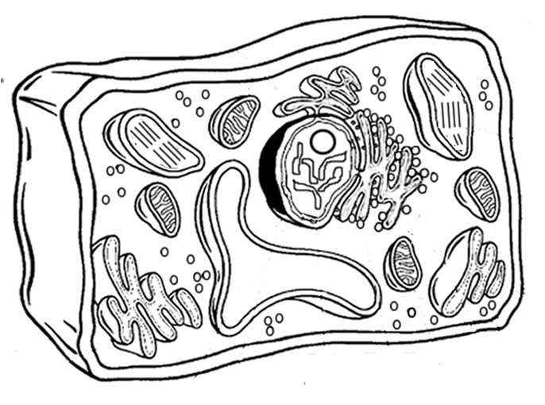

Analysis
1. Name two things found in a plant cell that are not found in an animal cell:
2. How does the shape of a plant cell differ from that of an animal cell?
3. What is the function of the chloroplasts?
4. What is the function of the vacuole?

Animal Cell Coloring
I. Directions: Color each part of the cell its designated color.
Cell Membrane(light brown) | Nucleolus (black) | Mitochondria (red)
Cytoplasm (light yellow) | Golgi Apparatus (pink) | Lysosome (purple)
Nucleoplasm (dark yellow) | Flagella (red/blue striped) | Microtubules (dark green)
Nuclear Membrane(dark brown) | Rough Endoplasmic Reticulum (dark blue) | Ribosome (orange)
 | Smooth Endoplasmic Reticulum( light blue)
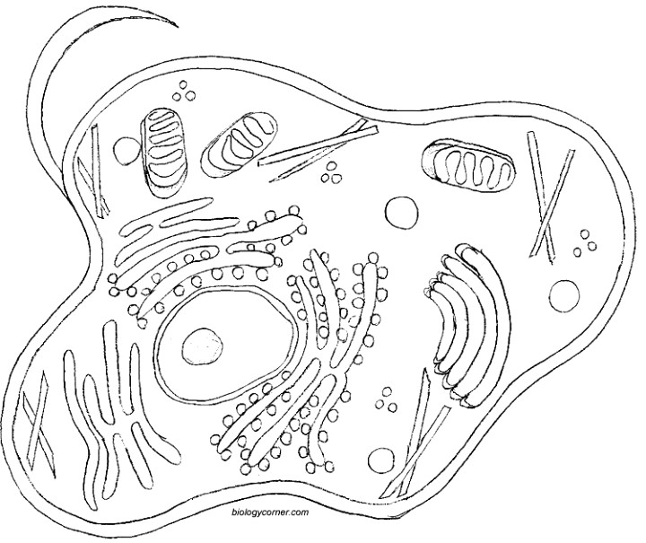
II. Briefly describe the function of the cell parts.
1. Cell membrane _________________________________________________
2. Endoplasmic Reticulum ___________________________________________
3. Ribosome ______________________________________________________
4. Golgi Apparatus _________________________________________________
5. Lysosome ______________________________________________________
6. Microtubule _____________________________________________________
7. Mitochondria ____________________________________________________
8. Nucleus ________________________________________________________

