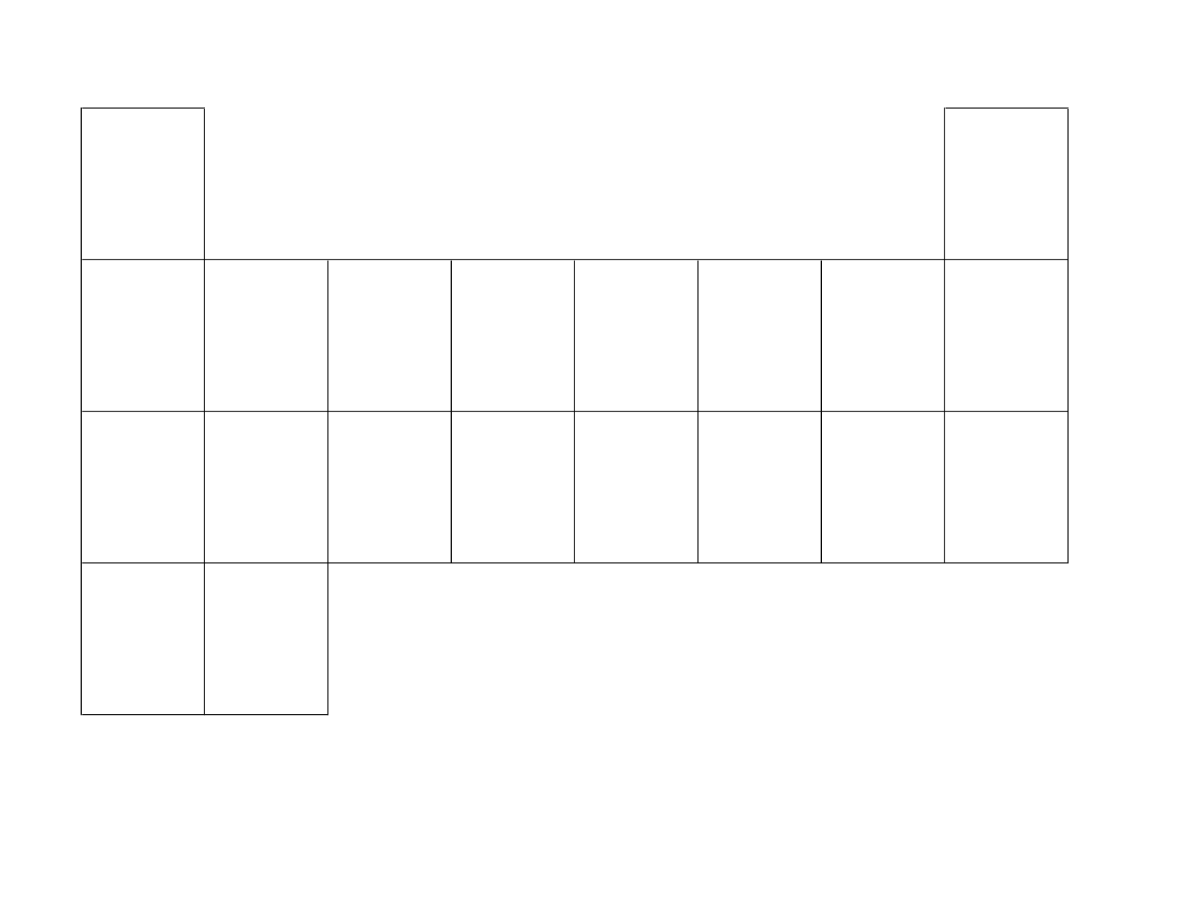

Bohr Diagrams



Lewis Diagrams