Organism Assignment
- Sign-up for an organism on the class sign-up sheet. Write down the name of your organism.
- Research your organism and document the following
  - Common Name
  - Classify according to any that are applicable (explain your choice for each)

    - Producer
    - Consumer
      - Primary
      - Secondary
    - Detritivore
    - Predator
    - Pray
    - Decomposer
    - Autotroph
    - Heterotroph

  - Diet

  - Appearance

  - Find each of the following:
    - 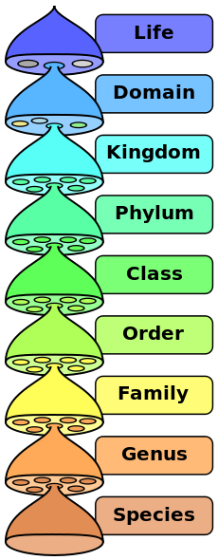

- Fill in the name & picture tag for your organism.

