Naming Compounds Tutorial and Worksheet
Since we use different methods in naming covalent (molecular) compounds and ionic compounds, the first step in naming or writing the formula of a compound is to determine which of the 2 compound classes it belongs. This can be done as follows:

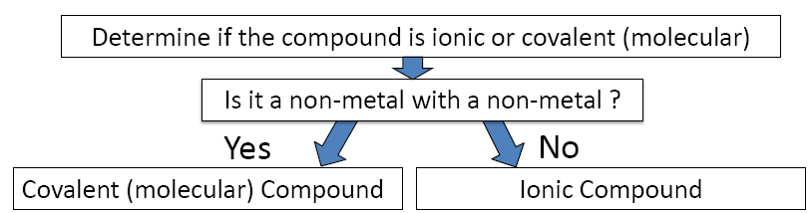

The only exception we will see to the above flow chart is when we see the polyatomic ion ammonium (NH4+) combined with any anion; in those cases the compound is ionic even though the compound is composed of non-metals only.

Once it is determined that the compound is ionic or covalent, the student can be asked to do either of the following:

- Given the name of the compound, write the formula.
Or
- Given the formula of the compound, write the name.

In this tutorial we will review the process for achieving these 2 objectives and practice with some worksheet problems. First, we will review and practice how to write formulas for compounds when given the compound’s name. Second, we will review and practice how to write the name of a compound when given the compound’s formula.

Writing Formulas for Compounds

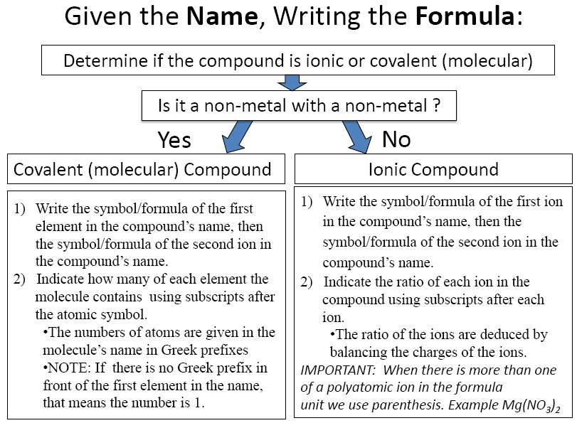

Chem 10 Name: _______________
Class: __________

A. Naming Ionic compounds
- Ionic compound: bonding between _______ & _______________
- Anion is a ______________ charged ion (Cl⁻, O²⁻, NO₃⁻).
- Cation is a _____________ charged ion (K⁺, Al³⁺, NH₄⁺).
- Monatomic: species made up of ____ __________ (Ne, Na⁺, I⁻).
- Diatomic: species made up of ___________ (O₂, NaCl, I₂, LiBr).
- Triatomic: species made up of _____________ (K₂S, O₃, H₂O).
- Polyatomic: species made up of ______________ (Poly means more than one). (CH₄, C₂H₆O, NaCl)

B. Exercise

1a) SO₄²⁻ ______________________ d) OH⁻ ___________________ __
b) H₂O ______________________ e) NH₄⁺ ______________________
c) Sr²⁺ ______________________ f) Ar ______________________

C. Naming Monatomic ions
- Naming monatomic metal ions
A. K --> K⁺ Potassium metal (or atom) forms the potassium ion.
Be --> Be⁺ Beryllium forms the _______________
    - If there is _______________ possible charge: use Roman numerals in brackets between the metal name and the word ion.
Example: Fe³⁺ = iron (III) ion, Fe²⁺ = iron (II) ion, Cu³⁺ = copper (III) ion.

- Naming monatomic non-metal ions: Change the ending of the non-metal to “ide”. (ide means that the ion has a negative charge.)

Element name | Symbol | Ion name | Ion symbol
Fluorine | F | Fluoride
Chlorine | Cl |  | Cl⁻
Bromine | Br | Bromide
Iodine | I |  | I⁻
Oxygen | O | Oxide
Sulphur | S |  | S²⁻
Selenium | Se | Selenide
Nitrogen | N |  | N³⁻
Phosphorus | P | Phosphide
Carbon | C |  | C⁴⁻

D. Polyatomic ions
- Polyatomic ions are compounds that carry a charge.
- Memorize the following polyatomic ions and their charges

Name | Symbol and Charge
Carbonate
 | NO₃⁻
Phosphate
 | OH⁻
Sulfate
 | MnO₄⁻
Chromate
 | CH₃COO⁻
Dichromate
 | NH₄⁺

E. Self-Test: Close your textbook. Give the symbol name the where the element name is given & give the element name where the symbol is given.
a) sodium | b) K | c) thallium | d) Hg
e) silicon | f) Kr | g) fluorine | h) Cr
i) sulphur | j) Cs | k) cadmium | l) Be
m) arsenic | n) Mo | o) platinum | p) Cu
q) tungsten | r) Pb | s) astatine | t)B

- Do you know these symbols and names?

F. Writing Formulas of Ionic Compounds

- Positive ion first & negative ion second
- criss-cross
- reduce if possible
- do not write the number 1

Answer: Na₂ (CrO₄)₁ --> ______________

Examples:
- Barium chloride = Ba²⁺ Cl⁻, Ba1Cl₂ ___________
- Barium Oxide = __________________
- Iron (II) phosphate= _______________

NAMING AND WRITING FORMULAS
FOR IONIC COMPOUNDS
A: Name the following compounds |  | B: Write the formulae for the following compounds
1) CaCl₂ |  | 1) sodium chloride
2) AgCl |  | 2) potassium bromide
3) MgO |  | 3) calcium iodide
4) NaBr |  | 4) zinc oxide
5) Al₂O₃ |  | 5) silver sulphide
6) KI |  | 6) potassium sulphide
7) ZnCl₂ |  | 7) barium hydride
8) Li₂O |  | 8) silver oxide
9) BaO |  | 9) lithium chloride
10) CaBr₂ |  | 10) hydrogen bromide
11) MgCl₂ |  | 11) magnesium chloride
12) AgI |  | 12) lithium nitride
13) ZnS |  | 13) zinc bromide
14) BaF₂ |  | 14) sodium iodide
15) Ca₃P₂ |  | 15) barium chloride
16) Na₂O |  | 16) potassium hydride
17) AlN |  | 17) aluminum sulphide
18) NiBr₂ |  | 18) calcium silicide
19) Ca₂C |  | 19) calcium sulphide
20) K₂O |  | 20) magnesium phosphide
21) H₂S |  | 21) barium carbide
22) Na₃N |  | 22) sodium hydride
23) LiF |  | 23) magnesium fluoride
24) AlCl₃ |  | 24) zinc nitride
25) NiO |  | 25) aluminum carbide

G. Naming Ionic Compounds

STEPS
- Uncross the charges and "ide" ending on second atom (Li₂O = Li⁺ O²⁻ = lithium oxide
- ( you are FINISHED IF cation only has one charge otherwise continue)
- What is total charge of anion? (ex. PbO₂ => O²⁻ x 2 atoms = -4)
- Cation must neutralize( Pb = +4)
- Use Roman Numerals to state combining capacity ( lead(IV) oxide)
Examples:
- MgBr₂ = Mg²⁺ Br⁻ = ____________________.
- K₂O = K⁺ O²⁻ = _______________________.
- Fe(OH)₃ = Fe³⁺ OH⁻= __________________ use polyatomic ion name
- FeO = Fe⁺ O⁻, = Fe²⁺ O²⁻ = ______________.
- WBr₆ = W⁺⁶ Br = ______________________.

A: Name the following compounds |  | B: Write the formulae for the following compounds
1) CuCl |  | 1) cobalt (II) chloride
2) FeO |  | 2) chromium (II) oxide
3) HgBr₂ |  | 3) gold (I) chloride
4) PbO₂ |  | 4) lead (II) fluoride
5) CrS |  | 5) copper (I) nitride
6) FeCl₃ |  | 6) tin (IV) sulphide
7) AuI |  | 7) copper (II) sulphide
8) Cu₂O |  | 8) manganese (III) oxide
9) PbS |  | 9) gold (III) sulphide
10) Hg₂O |  | 10) iron (III) sulphide
11) SnF₂ |  | 11) cobalt (III) oxide
12) AuBr₃ |  | 12) manganese (III) nitride
13) CrF₂ |  | 13) mercury (II) chloride
14) MnS |  | 14) sodium iodide
15) SnH₄ |  | 15) barium chloride
16) Fe₂O₃ |  | 16) potassium hydride

H. Naming Hydrates

Hydrate: a solid compound that contains water molecules.
  - Ex. Al₂O₃·3H₂O

Prefix | # of H₂O molecules  or # of atoms | Prefix | # of H₂O molecules  or # of atoms
mono | 1 | hexa | 6
di | 2 | hepta | 7
tri | 3 | octa | 8
tetra | 4 | nona | 9
penta | 5 | deca | 10

STEPS
- Name as ionic compound as you would normally do so.
- Add prefix from table and then “hydrate”

Example’s:
- FeSO₄·5H₂O = Iron (II) sulphate pentahydrate
- NiSO₄·7H₂O = ______________________________
- Co₃(PO₄)₂·8H₂O = ___________________________

I. Prefix Naming System: Is used when 2 non-metals form a binary compound (covalent)

STEPS
- Use prefixes from tables in front of elements
- Second element has “ide” ending
- Do not use mono on first elemrnt
- Do not use Roman numerals

Example: Right or Wrong
Monocarbon dioxide ____
Carbon dioxide ____
Carbon (IV) dioxide ____

Part A: Name the following covalent
compounds.

1. CO _______________________

2. CO₂ _______________________

3. N₂O₃ _______________________

4. N₂ _______________________

5. NP _______________________

6. SCl₂ _______________________

7. P₂O₅ _______________________

8. NBr₃ _______________________

9. CI₄ _______________________

10. CCl₄ _______________________

11. PF₅ _______________________

12. PF₃ _______________________

13. OS _______________________

14. SeF₂ _______________________

15. TeBr₂ _______________________

16. P₂S₅ _______________________

17. C₃N₄ _______________________

18. F₂ _______________________

19. CH₄ _______________________

20. PH₃ _______________________

Part B: Write the Chemical Formula for each of the following compounds.

1. carbon tetrafluoride ______________

2. silicon dioxide __________________

3. dinitrogen trisulfide ______________

4. phosphorus mononitride __________

5. hydrogen gas __________________

6. carbon disulfide _______________

7. nitrogen trichloride ______________

8. silicon tetrabromide _____________

9. carbon dioxide _________________

10. nitrogen trifluoride ____________

11. boron trisulfide _______________

12. sulphur trioxide ______________

13. selenium tetrafluoride ___________

14. diphosphorus pentasulfide _______

15. xenon tetrafluoride ____________

16. sulfur dibromide _______________

17. carbon tetrachloride ____________

18. oxygen gas _______________

19. fluorine gas _______________

20. dinitrogen tetroxide ________

