Introduction

Cells of the same type interact both structurally and functionally to form specialized tissues.
Tissues interact to form more complex structures known as organs.
Several organs are linked together either physically or functionally as organ systems.

Identify the system shown in each of the following diagrams.
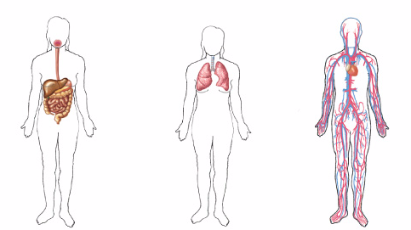

__________________ _________________ ___________________

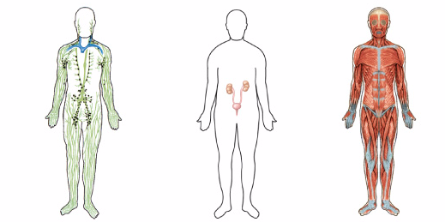

__________________ _________________ ___________________

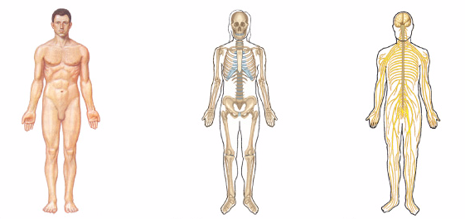

__________________ _________________ ___________________

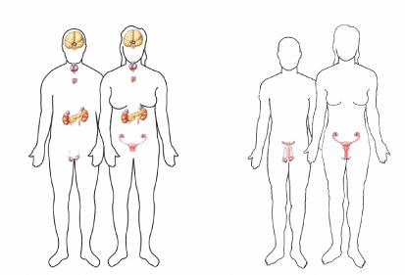

__________________ _________________

Provide a description of the functions of each of the human systems depicted on the previous pages.

System | Function

System | Function

