1. Use Figure 6.19 on page 217 of your textbook to label the diagram shown below.
2. Complete the chart that follows the diagram.

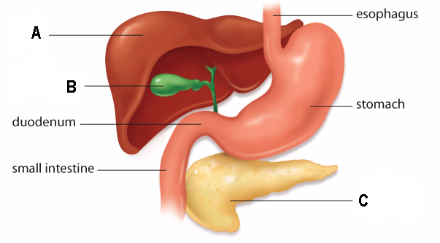

Label | Structure | Function
A
B
C

