1. Use your textbook to label the three diagrams shown below.
2. Summarize each diagram in the space provided.

Diagram 1: Absorption of Glucose

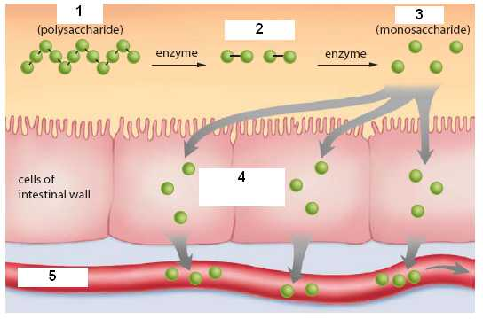

1. Summarize the digestion of starch and explain how monosaccharides enter the bloodstream.

______________________________________________________________________________
______________________________________________________________________________
______________________________________________________________________________
______________________________________________________________________________
______________________________________________________________________________
______________________________________________________________________________
______________________________________________________________________________
______________________________________________________________________________
______________________________________________________________________________

Diagram 2: Absorption of Amino Acids

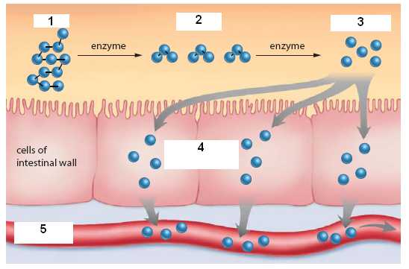

2. Summarize the digestion of proteins and explain how amino acids enter the bloodstream.

______________________________________________________________________________
______________________________________________________________________________
______________________________________________________________________________
______________________________________________________________________________
______________________________________________________________________________
______________________________________________________________________________
______________________________________________________________________________
______________________________________________________________________________
______________________________________________________________________________

Diagram 3: Absorption of Lipids

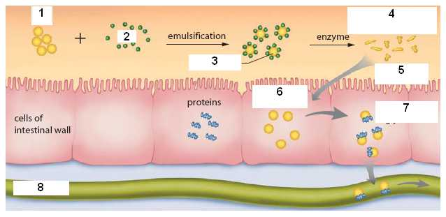

3. Summarize the digestion of fats and explain how lipids enter the bloodstream.
______________________________________________________________________________
______________________________________________________________________________
______________________________________________________________________________
______________________________________________________________________________
______________________________________________________________________________
______________________________________________________________________________
______________________________________________________________________________
______________________________________________________________________________
______________________________________________________________________________

