Chemistry 20 Bonding

A bond is any force that holds two atoms together.
There are four active forces that occur when any two atoms are near each other
e⁻
Blue is attractive (two forces)
Red is repulsive (two forces)
e-
The only way that a bond will naturally form is if the two attractive forces overcome the two repulsive forces.

When a bond does form, the bonding electrons will acquire a lower state of energy. They become more stable. This leads to a general energy principle on bonding; “Two atoms will bond only when they have less energy together than when they are separate”.

There are two basic types of bonds; ionic and covalent bonds. Ionic bonds occur when an outer electron is transferred from one atom to another producing an anion and a cation which attract. A covalent bond occurs between two atoms of similar attraction so they “share” some of their valence electrons. Ionic bonds form ionic compounds while covalent bonds form molecular compounds.

Ionic Bonding | Molecular Bonding
Metallic Bonding
Bonding Strength and Periodic Table Trends

There are many factors that affect the ability of two atoms to bond, but the two main factors determining the strength of an ionic bond are:
The size of the atom or its radius (number of orbitals).
How positive the nucleus is (number of protons).
Larger metal atoms with fewer protons and more orbitals can most easily lose their electrons. (Down and to the left on the periodic table). Smaller nonmetal atoms with more protons and less orbitals can most easily gain extra electrons. (Up and to the right on the periodic table).
It is possible to compare the strengths of ionic bonds by looking at these two factors.

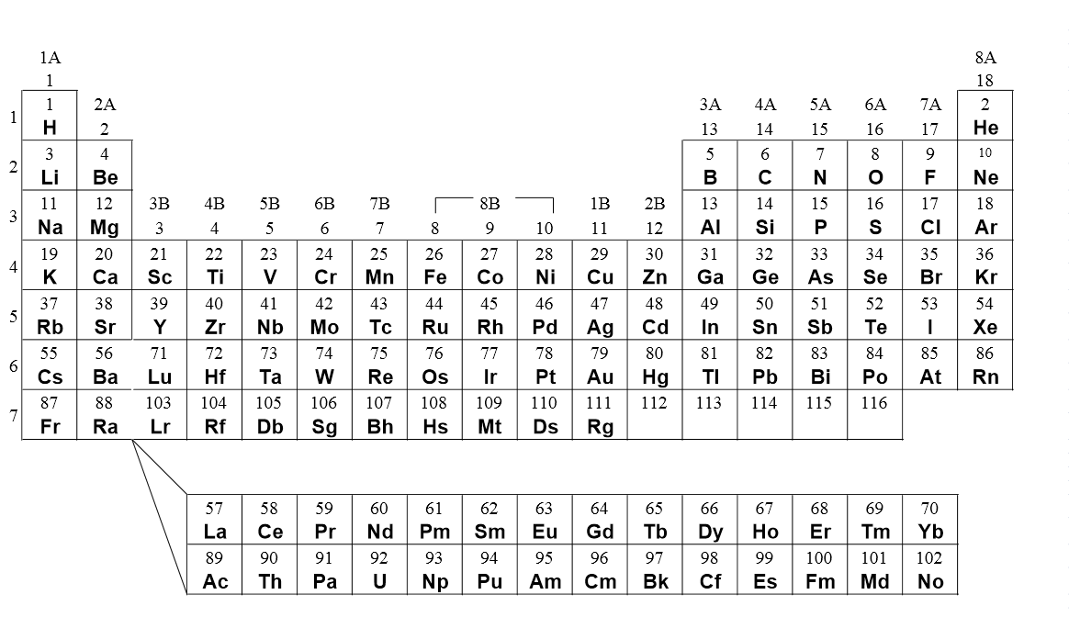

Ionization energy is the amount of energy required to remove the outermost electron of an atom. This produces an ion.

It is possible to depict molecules and their covalent bonds. Scientists have developed rules that allow us to predict how electrons are being shared. One major contributor to these rule was a scientist named Lewis. The foundation for Lewis theory rely on two basic principles:
Covalent bonds only occur between nonmetals, since they have similar attractions.
All atoms want to have a full outer orbital. (Octet rule)

Rules for Lewis bond diagrams:
- Each atom in a molecule has an individual symbol.
- All valence electrons are indicated.
- Any unpaired electrons are available for bonding.
- Paired electrons are called “lone pairs” and do not bond.
- The atom with the most unpaired electrons is (usually) the central atom.
- All electrons must pair up and the outer orbital is full.

Electronegativity is a value from 0 to 4 representing the ability of an atom to attract an electron. The general pattern on the periodic table is that electronegativity increases up and to the right. This does not include the noble gases. Atoms with a higher electronegativity have a greater ability to attract electrons.

If two atoms have similar electronegativities, they will share electrons or form covalent bonds. If two atoms have substantially different electronegativities, they will form ionic bonds. This gives rise to new definitions for bond types.

Atoms that bond and have a difference of electronegativity greater or equal to 1.8 will form ionic compounds with ionic bonds. Bonding atoms that have a difference in electronegativity less than 1.8 will form molecular compounds with covalent bonds. We also find that there are two types of covalent bonds: non polar covalent bonds and polar covalent bonds.
Nonpolar covalent bonds are drawn with a dash ( - )
Polar covalent bonds can be shown as an arrow with a positive sign to show the direction electron pairs are shifted between atoms. ( + )
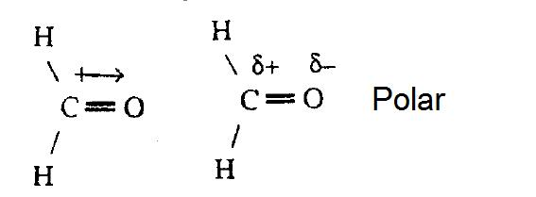
eg.
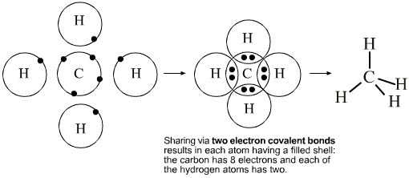

Lewis diagrams can be used to produce structural diagrams which include specific bond types.
Analyzing the bond types in a molecule and identifying general overall shifting of electrons allow us to predict whether a molecule has a dipole or not. Polar molecules have an overall shifting of its electrons in one direction more than another. Nonpolar molecules may not have any electron shifting or may have electron shifting, but the shifting is balanced in all directions.
eg.

