Name: ____________________

Natural Selection PhET Simulation

1) Play with the simulation for five minutes. Be prepared to share what you have found!

2) Fill in the table below with your observations.

How can you… | What did you change? | How many generations did it take?
…make more white bunnies?
…make 20 brown bunnies?

3) Challenge 1: Find a way to make the bunnies take over with brown fur! Fill in the table with your selections.

Mutation | Environment | Selection Factor | Observations
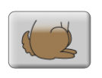
Brown fur

4) Challenge 2: Find a way to make 200 bunnies when food is a selection factor! Fill in the table with your selections.

Mutation | Environment | Selection Factor | Observations

5) Challenge 3: Find a way for the bunnies to take over when the environment is the artic! Fill in the table with your selections.

Mutation | Environment | Selection Factor | Observations
 | Arctic

6) On your own: Simulations are useful for understanding how natural processes work but are not always representative of the real world. How does this simulation differ from what might happen in a true ecosystem?

________________________________________________________________________

________________________________________________________________________

________________________________________________________________________

________________________________________________________________________

________________________________________________________________________

________________________________________________________________________

________________________________________________________________________

7) On your own: What changes would you make the simulation to make it a better representation of a true ecosystem?

________________________________________________________________________

________________________________________________________________________

________________________________________________________________________

________________________________________________________________________

________________________________________________________________________

________________________________________________________________________

Name: ___________________

Vocabulary Words

Word | Definition | Examples from simulation
Trait
Adaptation
Mutation
Limiting Factor
Biotic
Abiotic
Natural Selection

Name:____________________________________ Date:______________________

Show What You Know: Natural Selection

- Use the graph below to answer the following questions:

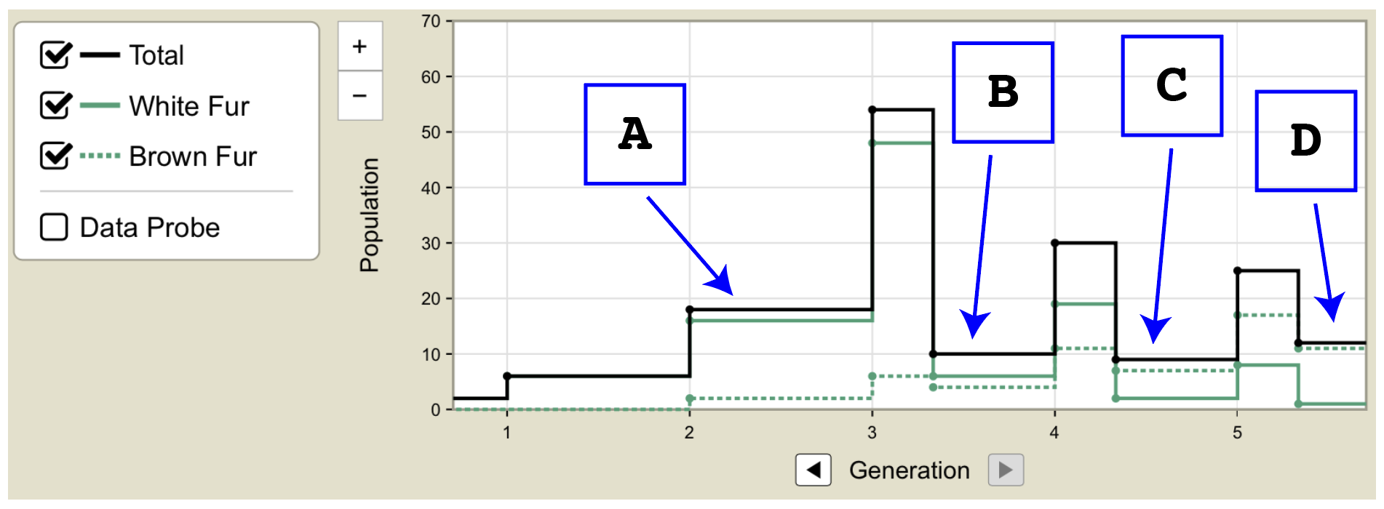

  - When do we first see more brown rabbits in the population than white ones? Circle the letter for the correct time point.

A B C D

  - Which time point shows when predators (wolves) were first introduced in to the rabbit’s habitat? Circle the letter for the correct time point.

A B C D

- Which of the following is an example of a limiting factor in an ecosystem?

  - Food
  - Number of predators
  - Amount of space
  - All of the above

- When the insecticide known as DDT was first introduced, it was highly effective. Which of these is the most likely reason that DDT became less effective as an insecticide?
  - rain caused DDT to be washed away in water runoff
  - insects resistant to DDT survived and reproduced successfully
  - biological magnification decreased the number of insect predators
  - changes in the types of crops grown caused changes in the types of pests

- A pack of wolves that normally live in warm weather experience a climate change that creates a new arctic environment. After many generations, the wolves develop many adaptations including sharper teeth and thicker fur. For surviving the colder climate, what types of mutations are those adaptations?
a. Sharper teeth and thicker fur are both positive mutations
b. Sharper teeth is a neutral mutation and thicker fur is a negative mutation
c. Sharper teeth is a negative mutation and thicker fur is a neutral mutation
d. Sharper teeth is a neutral mutation and thicker fur is a positive mutation

- Describe ways the simulation was limited in Challenge 2 (limited food for bunnies) and what are some modifications that can be made to the simulation so that it more closely resembles real life?

________________________________________________________________________

________________________________________________________________________

________________________________________________________________________

________________________________________________________________________

________________________________________________________________________

________________________________________________________________________

________________________________________________________________________

________________________________________________________________________

________________________________________________________________________

________________________________________________________________________

________________________________________________________________________

________________________________________________________________________

