Name: ______________________________________________

Peppered Moth Game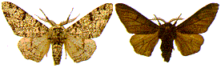

Objective: Simulate changes in moth population due to pollution and predation, and observe how species can change over time.
Go to: https://askabiologist.asu.edu/peppered-moths-game/play.html and read each section before you play the game, answer the questions as you go.

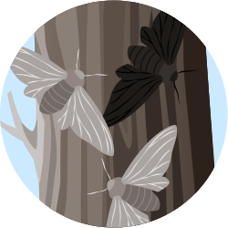

Peppered Moth
1. Where do peppered moths live? ______________________________________________
2. How do the moth larvae survive predators? _________________________________________
3. What do the moths do during the winter? ______________________________________
4. What color is the "typica" version of the moths? _________________________
What color is the "carbonaria" version? _______________________________
5. How do adult moths survive predation? _________________________________________

Natural Selection
6. What was the industrial revolution? _____________________________________________
7. What was causing the change in the color of the moths? ______________________________
8. What is natural selection? _______________________________________________________
9. Why would dark moths have an advantage? ___________________________________________

Dr. Kettlewell
10. What is an entomologist? ________________________________________________________
11. How do scientists test theories? ____________________________________________________
12. Dr. Kettlewelll predicted that clean forests would have _____________ colored moths, and polluted forests would have _________ colored moths.
13. How did Kettlewell test his hypothesis? ________________________________________________
14. How did Kettlewell determine if moths lived longer than others? _____________________________________

Play the Game
15. Complete the data table for the light forest and the dark forest.

Final Analysis
16. Explain how the color of the moths increases or decreases their chances of survival.

17. Explain the concept of natural selection using your moths as an example.

18. Predict what would happen if there were no predators in the forest. Would the moth colors have changed? Why or why not?

19. Efforts to reduce pollution began occurring later in the century. If pollution near factories was reduced, what would happen to the color of the moths? Explain your answer.

20. Kettlewell's experiment is included in most biology texts as an example of evolution occurring. How do we know that the moths evolved?

