PhET: Reactions and Rates

Getting Started: Go to http://standring.weebly.com/unit-6---thermochemistry.html run the simulation at the bottom of the page.

Part 1: Single Collision
Learning Goals: By looking at a single chemical reaction, you will understand the conditions necessary for a successful chemical reaction according to Collision Theory as well as the uses of a potential energy diagram.

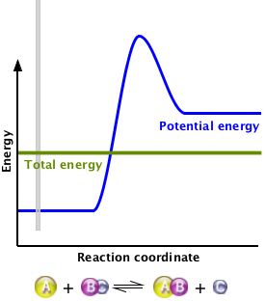
Procedure:
- Make sure you are on the “single collision” tab.
- Click on the plus sign next to ‘energy view’ to view the potential energy diagram.
- Starting with the ‘straight shot,’ play with the different reactions.
- Try designing your own.
- Change the launcher options to angled shot. (Top right box)
- Play with the different reactions, try designing your own.

Analysis:
- Pick one of the reactions (can be design your own). Draw the potential energy diagram below.

- Label the reactants, products, and activated complex.
- Draw the line segments representing the activation energy and reaction energy. Label.
- On your diagram, draw the line representing where the total energy needs to be in order to have a successful reaction. Label.

- Do the reactants or the products have more energy?

- Is this reaction endothermic or exothermic?
Part 2: Many Collisions
Learning Goals: By analyzing graphs and patterns, you will understand how systems reach and behave at dynamic equilibrium.

Procedure:
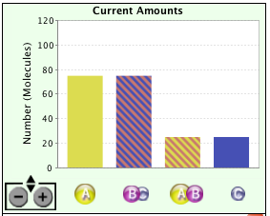
- Change to the tab labeled ‘Many Collisions.’
- Under options, select ‘bar graph.’ Zoom the bar graph out until you can see the 100 label of the y-axis.
- Add 100 molecules of each of the reactants to the equilibrium mixture.
- Let the reaction continue for AT LEAST 5 MINUTES, until the counts stay relatively steady. Make note of how the values change and the final values.
- Clear the container.
- Now, add 100 molecules of each of the PRODUCTS to the equilibrium mixture.
- Let the reaction continue for AT LEAST 5 MINUTES, until the counts stay relatively steady. Make note of how the values change and the final values.

Analysis:
- What do you notice about the position of the equilibrium? Is it favored to the reactants or products?

- Compare the equilibrium position to the potential energy diagram for the reaction you drew in part one. What do you notice?

- How did the reaction rates of the forward and backward reaction change as the system got close to equilibrium?

- You saw what happened when we started with only reactants, and with only products. What do you predict would happen if we started with half and half? Why?

- These numbers are VERY small compared to the actual interactions of molecules, try to think of how small 200 is compared to a mole, 6.02 x 10²³. Our numbers fluctuated quite a bit, how much do you think the fluctuation is at such large numbers?
PhET Mini-Lab: Reactions and Rates (2)

Part 3: Rate Experiments
Learning Goals: Using the simulation, you will investigate how the equilibrium position shifts when something upsets the system.
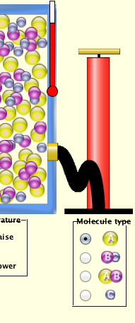
Procedure:
- Switch to the “Rate Experiments” tab.
- Select options to display bar graph and energy diagram.
- Add molecules to the system and allow it to reach equilibrium as we did in Part 2.
- Now, select a molecule under the ‘pump’ to pump into the system.
- Add two ‘pumps’ of that molecule. Note how the numbers of the molecules in the system change and the rate at which they change.
- Let the system reach equilibrium. Note how the equilibrium position has changed.
- Try again with a different molecule.
- Once the system is at equilibrium, change the temperature in the system. Note how reaction rates and the position of equilibrium change.

Analysis:
- How did adding a reactant or a product affect the rates of the reactions as soon as it was added?

- How did adding a reactant or product change the position of the equilibrium once a new equilibrium was established?

- How did changing the temperature affect the system?

