MOLECULE POLARITY

PART I: TWO ATOMS SCREEN

- Explain all the ways you can change the polarity of the two-atom molecule.

- Record your ideas in the table below.

Representation | How does each change as electronegativity changes? | How does each help you understand the polarity of molecules?
Bond Dipole

Partial Charges

Electrostatic Potential

PART II: THREE ATOMS SCREEN

- Explain any new ways to change the molecule polarity of the three-atom molecule.

- How does the ABC-bond angle effect molecule polarity? Tip: Try changing the bond angle in the simulation.

- Explain the relationship between the bond dipoles and the molecule dipole.

- Can a non-polar molecule contain polar bonds? Use an example to explain your answer.

PART III: REAL MOLECULES SCREEN

- Predict the polarity of four real molecules in the simulation. Explain your reasoning before you check your predictions with the simulation.

YOUR PREDICTION |  | CHECK  Your Prediction
Draw Molecule -  Include Bond Dipoles & Molecule Dipole | Explain Your Reasoning: | Correct? Explain any differences.

- Discuss with your group the method(s) that you used to determine the bond dipoles and the molecule dipole. Write your method(s) in complete sentences below.

EXERCISES
Molecule | Molecule Geometry | Is the Molecule Polar? Explain Why or Why Not.
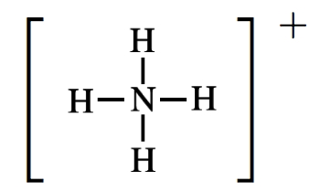
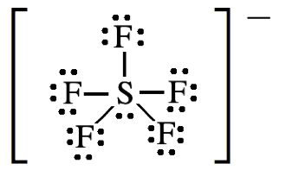
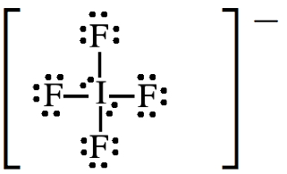
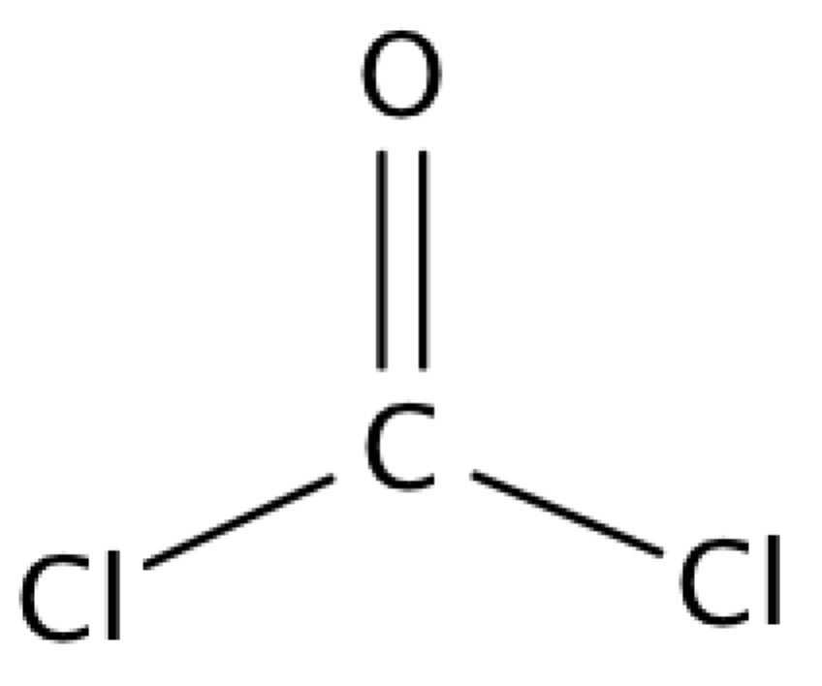

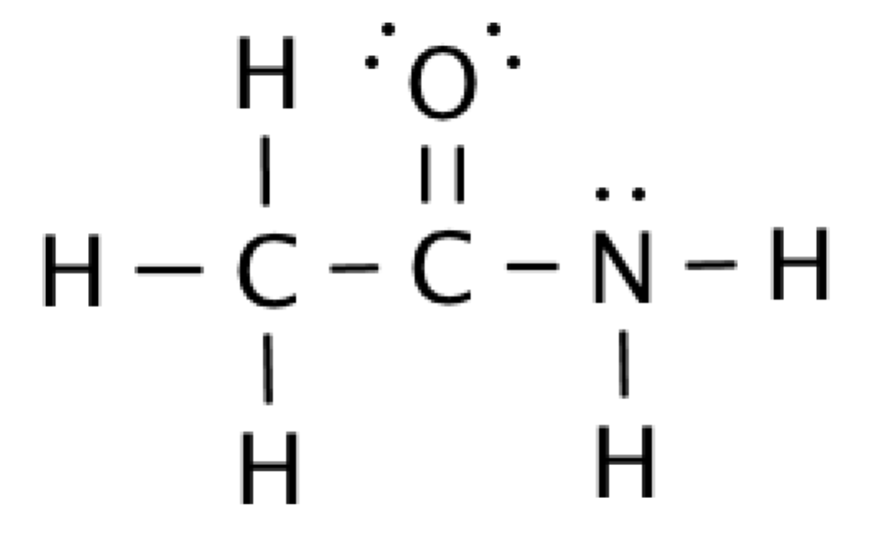
Determine the Molecule Geometry and Polarity of the following molecules.

CHALLENGE PROBLEMS:
For each molecule below: Determine the Lewis structure and molecule geometry. Draw the molecule using wedges to show three-dimensionality. Finally, determine if the molecule is polar. If so, draw an arrow to show the molecule dipole.

- CHO₂⁻¹

- PF₃

- AlCl₃

- CHBr₃

- H₂S

- SiCl₄

- HCCBr

- CH₂CHCHCH₂

- BrF₄⁺(Br is central atom and has 10e⁻ in its valance shell)

